фото | артикул | Цена(USD)
 | FD010 | 4.2
 | FD011 | 4.5
 | FD013 | 3.5
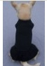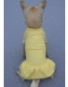 | FD014 | 3.8
 | FD015 | 4.2
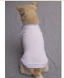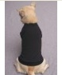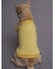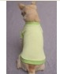 | FD017 | 3.8
 | FD019 | 4.3
 | FD020 | 3.5
 | FD022 | 4
 | FD023 | 4.5
 | FD024 | 3.7
 | FD025 | 3.8
 | FD027 | 4.8
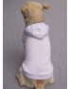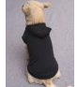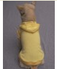 | FD028 | 3.7
 | FD029 | 3.8
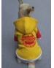 | FD030 | 3.9
 | FD033 | 5.2
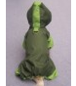 | FD036 | 5
 | FD038 | 4
 | FD044 | 5
 | FD050 | 4
 | FD051 | 4
 | FD052 | 3.8
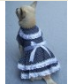 | FD053 | 4
 | FD054 | 4
 | FD055 | 4
 | FD060 | 5.5
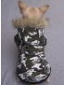 | FD063 | 5.5
 | FD065 | 5.5
 | FD066 | 4.8
 | FD 072 | 5.5
 | FD073 | 5.2
 | FD074 | 5.2
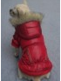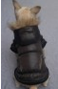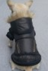 | FD075 | 5.5
 | FD076 | 5.8
 | FD080 | 4.5
 | FD081 | 4.5
 | FD082 | 4.5
 | FD083 | 4.5
 | FD084 | 4.5
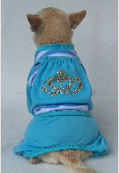 | FD085 | 5
 | FD090 | 4.2
 | FD091 | 4
 | FD092 | 4
 | FD093 | 4.2

